Team Number: 10
Team Members: Chen Lu, Zhaoyang Xue, Jiayi Fu, Yuyang Fan, Haoxuan Feng
Project Name: i-kun
Project Synopsis: First-person shooter game based on Unity Engine.
Architecture
Introduction:
Unity is a 2D/3D engine and framework that provides you with a system for designing game or application scenarios in 2D, 2.5D and 3D. Unity allows you to interact with them through code and visual components, and export them to every major mobile platform for free, Unity supports all major 3D applications and many audio formats, and even understands the Photoshop .psd format, so you can only Just drag and drop the .psd file into the Unity project. Unity allows you to import and assemble assets. Unity is a native C++ based game engine. At the same time Unity allows you to test your game in the IDE without having to do any kind of export or build. The Unity software interface consists of two views, three windows, four bars.
Two views: Scene view, Game view
Scene view: The place to edit the scene. The scene can be simply considered as each level in the game. Basically, all the elements that can be seen in the game are included in the scene, which can be edited and operated through the scene view.
Game view: The placement of the final execution effect of the game
Three Windows: Project Window, Hierarchy window, Inspector window
Like many powerful visual window software, each group of related functions will be designed as a window, and users can operate this series of functions through this window. The unity menu bar window contains the function windows that can be used in Unity. Here, first introduce the three most important ones.
Project Window: Resource Library
Hierarchy window: Hierarchical window, game objects are displayed hierarchically in this window, which can quickly locate the objects we want to operate, and clearly show the relationship between objects
Inspector window: Inspector window, also known as property window, can view and configure various properties of the selected object. Different objects have different layout and content.
Four bars: Title bar, Menu bar, Toolbar, Status bar
The standard layout position that basically every window standard windows application includes
Title bar: title (icon-project name-project default packaging method-unity version number-visualization API used) and control buttons (minimize-window/Fullscreen-close)
Menu bar: where all functions can be found
Toolbar: Commonly used basic operations
Status bar: unity information feedback
Game concept：
In the beginning of the game, users will be asked to select a game mode and level of difficulty. Once the player has selected the option, they will be prompted to a screen telling them the game is loading/ queued in game. Once the game is loaded, the user will be put into a game. When the game starts, the player will try to find harmful cells and try to eliminate them within a certain time limit (based on the level of difficulty chosen by player and game option). The player also needs to be cautious when running around the map because there could be props and enemies that can harm the user. If the user gets infected, then the user loses.

Technology Diagrams:
Our program has a three-layer architecture, namely UI Layer, Game world, and Data Layer. In the UI layer, we start from the menu, where the user can choose to enter the setting interface, or enter the game developed based on Unity and C#. In the Game world, the map is the main body of our interface. There will be the user's character on the map, as well as enemies. Among them, the user has attributes such as HP, weapon (bullet), score, etc. Enemies only have HP attributes. In the data layer, we transfer the HP of the user and the enemy, the user's weapon, and the score to this layer for recording and calculation.
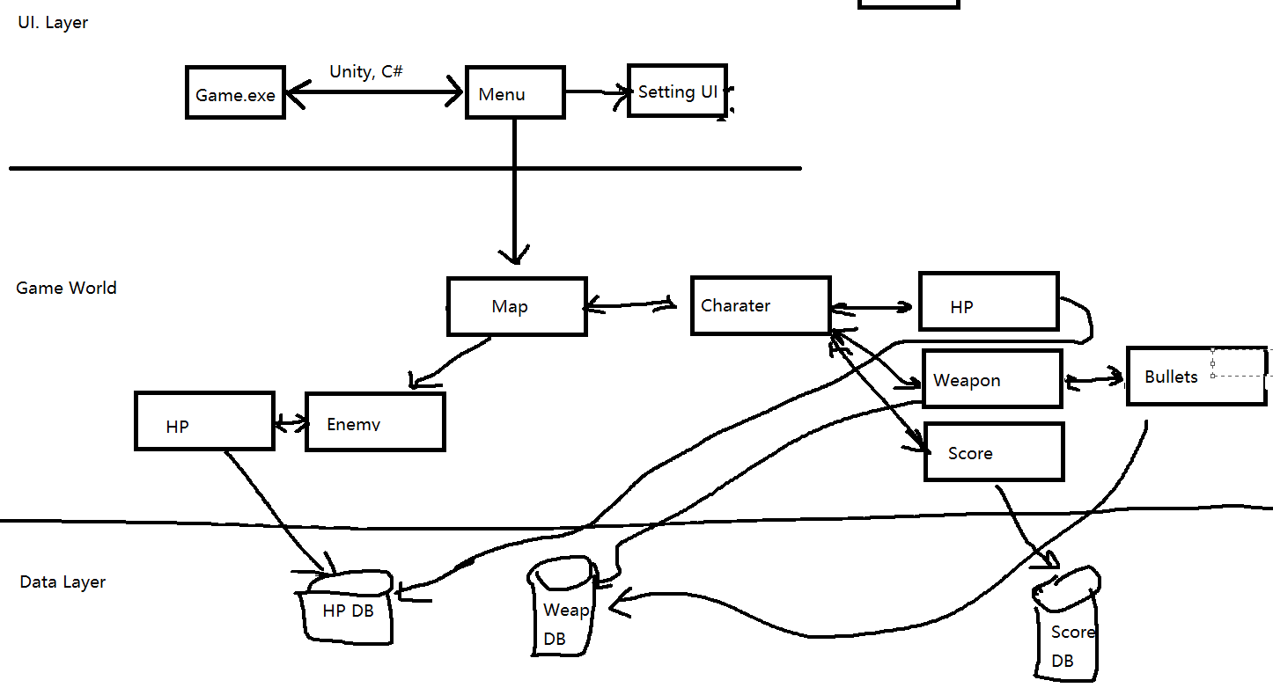
UI: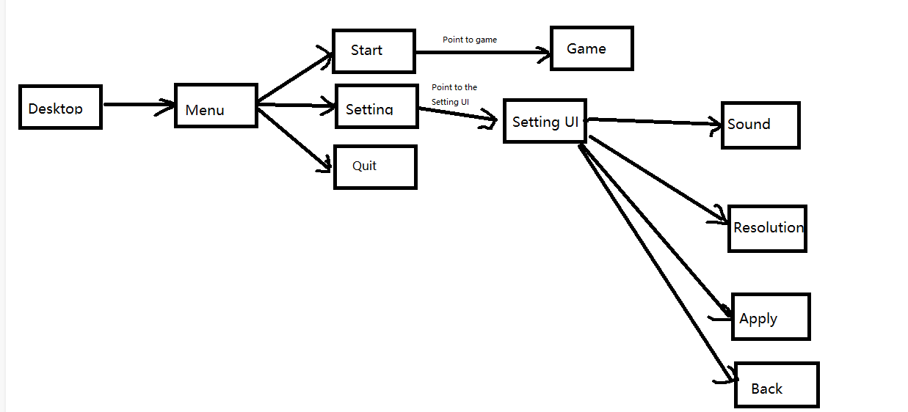
Video games have common UI components that help players navigate, find information, and accomplish goals. From start screens to counters, video game UI components are a key aspect of playability. UI components exist in both the game's story and space, and while they exist in the game's story and space, make sure not to distract the player.
A life meter may be narrative in one game but non-narrative in another. Depending on the game's narrative and the player's relationship to the fourth wall, components can blur the lines between classes.
Often used as a visual aid to help players select objects or point out important landmarks. Text labels are a classic example of spatial UI components. During the game, players may encounter important objects that look unfamiliar. Text labels quickly disambiguate and immerse players in the gaming experience.
Main menu:
The menu can lead users to the game starting part. However, before starting the game, users can go into settings to flexibly adapt to their computer.
The setting contains several functions, which are sound control, window size control, resolution control. For the sound, users can control the volume by dragging the cursor and the volume range is from 0% to 100%. Users can adjust the volume until they reach the appropriate volume. What’s more, users can choose suitable window size and the appropriate resolution. The window size can be Fullscreen or windowed screen.
Designing an effective main menu requires finding a healthy balance between engaging players and satisfying their desire to get into the game as quickly as possible. In order to create any kind of UI, Place the container first. Order is critical in code and hierarchies, if your order fails, you will not see your UI objects displayed on the screen viewport. UI images can be pixel resized to fit any regular monitor 720p - 4k.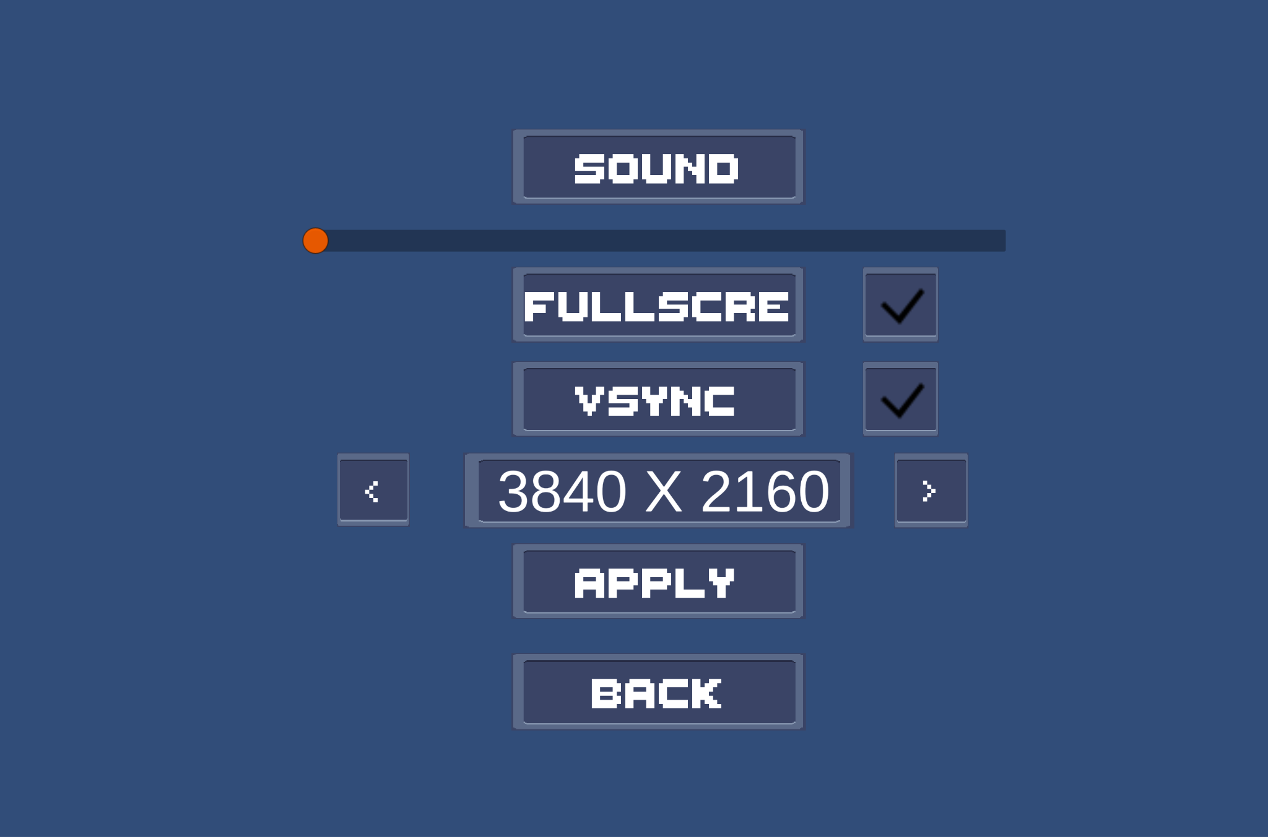

Animation controller:
Animations of enemies, NPCs, and other models will be controlled through Unity's built-in animation controller in our game. The Animation controller in Unity is a controller that controls the sequence and firing conditions of animations. As shown in the illustration, the boxes store specific animation, and the pointer represents its running order and trigger condition. In the future of the game, we will use c# code to connect the trigger conditions in Unity to control the animation.

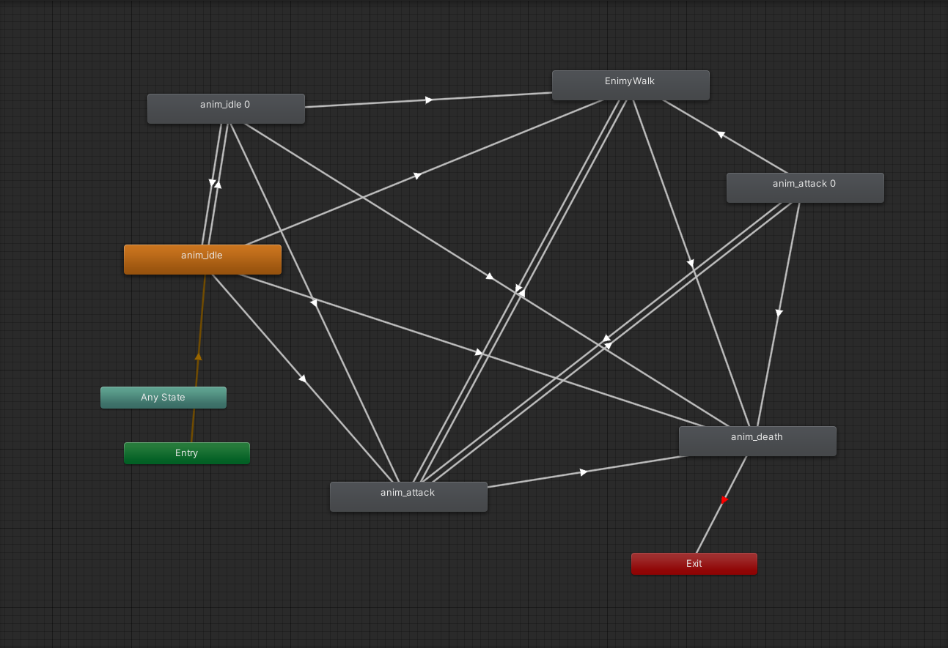
(Animation controller in unity)

AI:
First-person shooters are a very specific and popular genre of video games. Many the general AI principles and techniques of FPS AI apply, but they require Modified to cater for fast-paced action. The challenge is to efficiently select, modify, and combine algorithms so that the AI ​​can react quickly to the player, determine position, orientation, and game logic for all game entities. The AI ​​system also includes controller logic, player animation, physics, navigation and processing effects, and sound.

Map:
The map contains a lot of constituent elements, for instance, shadow rendering, climate change, Global Illumination Change and so forth.
The climate includes sunny, windy, foggy, snowy days and so on. Every several hours, the weather will randomly and automatically change. In addition, each weather is corresponding to its own effect. For example, snowy days may cause cold de-buffs, and foggy days may cause shorter insights.
The shadow rendering can make the scenery more real. For example, the building may cause shadow because of its height.
Global Illumination Change the direction of directional lights and simulate the effect of the sun moving across the sky. Directional lights that create realistic time effects that update at runtime. Over time, sunlight hits the building, and this light hits the room and bounces off the floor to create shadows. Makes it start glowing into its surroundings when turned on.

Intention:
The original intention of this project is to realize the dream we have always dreamed of. We all have played various shooting games during our college life, and we are eager to make our own game. Although there may be a lot of obstacles on our way to the final achievement, we not only enjoy the time working with our best friends, but also can improve our ability of teamwork.

Conclusion:
By the end of this project, we will have implemented a game that can be played on PC. Our goal is to make this program friendly to people of all ages. While there will be gun violence in the game, we want it to be as friendly as possible.

